Referential Integrity
Referential Integrity refers to the accuracy and consistency of data within a relationship. Referential integrity requires that, whenever a foreign key value is used it must reference a valid, existing primary key in the parent table. A DBMS will enforce this integrity. These next steps assume you have completed SQL - The basics If you haven't please go back and complete those steps.

Trying to Break Integrity

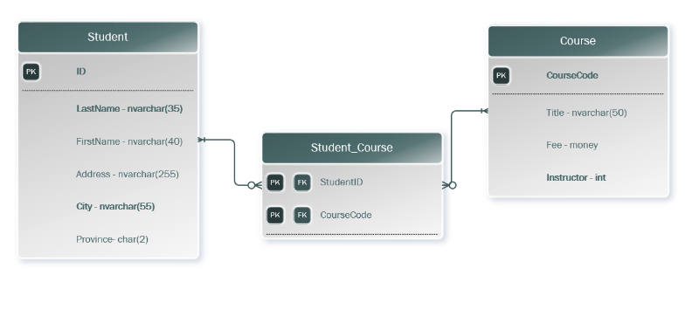
Above is an ERD of the current demo. Notice that there is a FK relationship between Student_Course and the student and Course tables. When these relationship are put in place in our DBMS, like we did at the end of the last exercise, the DBMS will enforce this relationship.
This means if we try and break our relationships integrity by say dropping the course table when Student_Course is relying on it:
DROP TABLE Course;
This will fail, we will get the following error:
Msg 3726, Level 16, State 1, Line 57
Could not drop object 'Course' because it is referenced by a FOREIGN KEY constraint.
So we have two possible options, we can:
- Drop the foreign key constraint:
  - ALTER TABLE Course DROP CONSTRAINT FK_CourseCode;
  - Than drop our table:
  - DROP TABLE Course;
- OR we can make sure we drop the tables in an order that doesn't break our integrity
  - DROP TABLE Student_Course
DROP TABLE Student
DROP Table Course

